Full names: Ntombikayise Nhlanhlakazi Mtshweni
Student number: ST10529682
Subject name: Web Development (WEDE5020)
Group no. 3



Table of Contents
Organisation 2: Woolworths (Retail store) 3
1. Organisation Overview: 3
2. Website goals and objectives 4
3. Current Website Analysis 4
4. Proposed website Features and Functionality 4
5. Design and User Friendly 5
6. Technical Requirements: 9
7. Timeline Milestones: 9
8. Budget 9
9. References 9

Organisation 2: Woolworths (Retail store)

Organisation Overview:
• Name: Woolworths

• Brief history of organisation: Woolworths, located on various parts of the Southern Africa, including Botswana, Kenya and Zimbabwe (2) (3) (4), is a retail store, which sells high quality goods, including food, clothing, beauty products, and home essentials. The first Woolworths, which was founded by Max Sonnenberg, October 30, 1932, was in Cape Town, in the dining room of the old Royal Hotel, which was then spread to other parts of the country (2).

• Mission and vision statement:
- Vision: “‘To be one of the world’s most responsible retailers'
Reflects our passionate commitment to doing good business, for our customers, our people and our planet” (2)

- Mission: “‘Adding quality to life ‘
Exceptional quality in every product we sell and every experience we deliver, to our customers and our people.”(2)

•Target audience: “Middle-to-upper-income consumers, families, and quality-conscious shoppers looking for premium food, apparel, and lifestyle products” (2) (5)

Website goals and objectives

- The aim for the website is to populate what is being sold in the store; from clothes, to makeup, to food, and many more; it’s main aim to display what is being sold to attract potential customers. The website displays various catalogues for the various items being sold. It is displayed like an online app, which can also indicate to the consumer that you are able to buy your items online.
- The Key Performance Indicators (KPI) for this retail store are the number of customers, the number of repeat visits.(2)

Current Website Analysis

Strengths:
- There is a space where you can enter your personal details, should you want to use the app.
- Website is organised well into categories

Weakness:
- The website is hard to navigate.
- The information given on the website is overcrowded

Proposed website Features and Functionality
- Shop By Department
  - Items sold are divided into departments (Food, Women, Men, Kids, Baby, Home, Beauty, WConnect) to make shopping easier.
- WCellar
- Gifting
- Re-order food

Design and User Friendly
- Colour Scheme: Black and White (and a hint of green).
- Typography: Primary font – Fresh Sans
- Layout and design: Designed as a one-page, so that the user is able to briefly see what ever is being sold to their potential customers. The layout is displayed as an online store, so customers can get the idea that items can be bought online.
- User experience considerations: The layout is done in such a way that the user can easily buy items online, as the website is similar to their website.
- Low-fidelity wireframe:

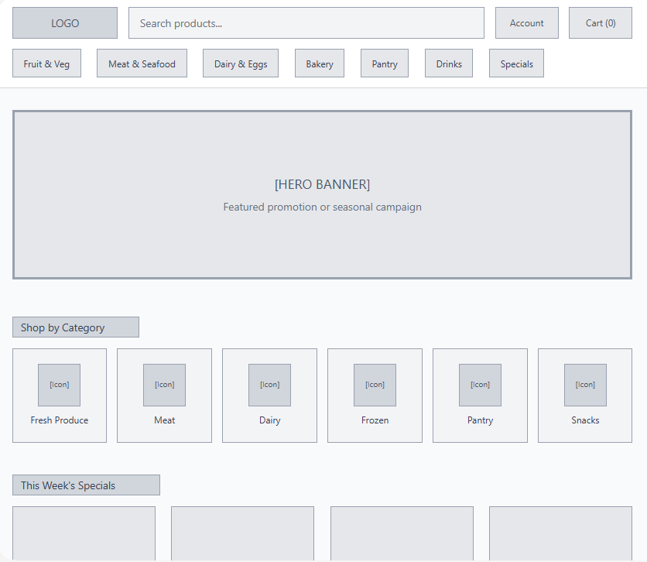
Homepage:
Contact: 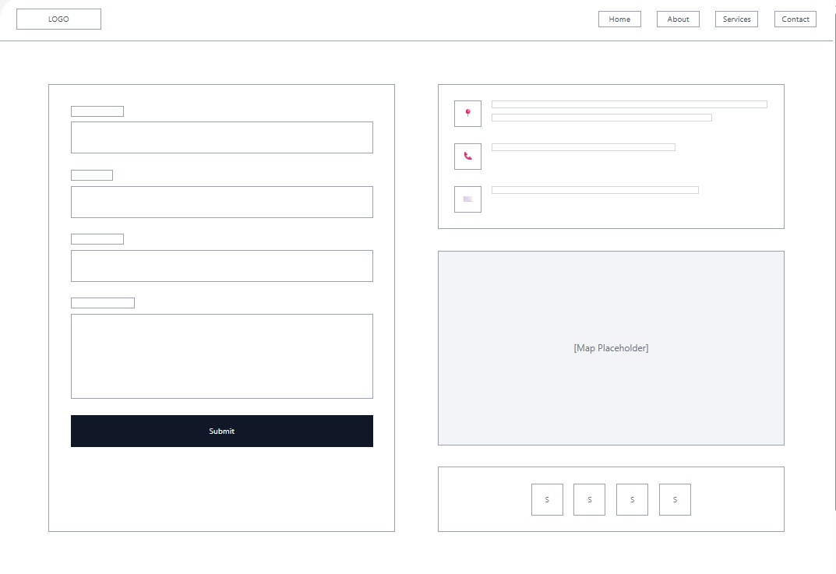
Enquiry: 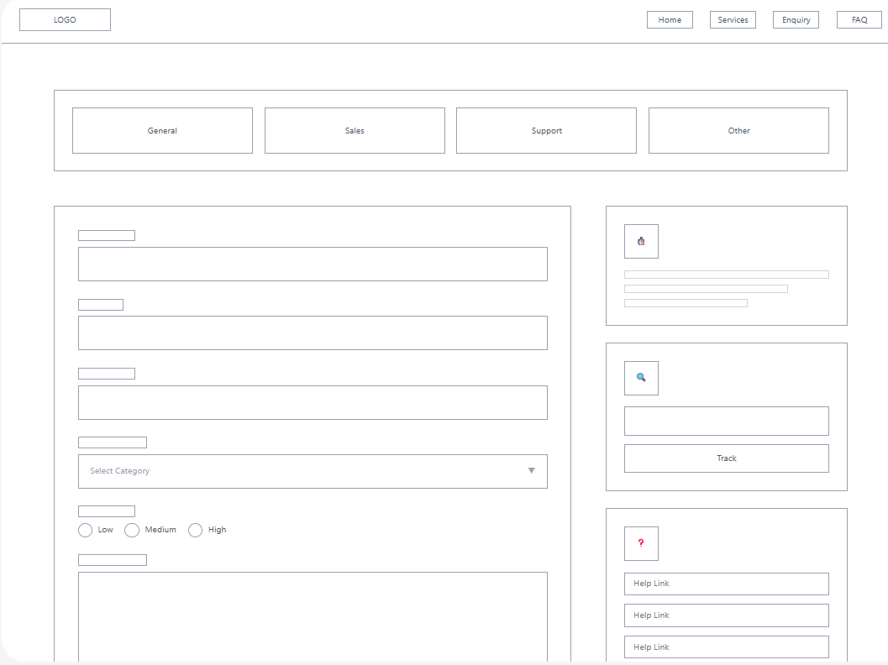
Products: 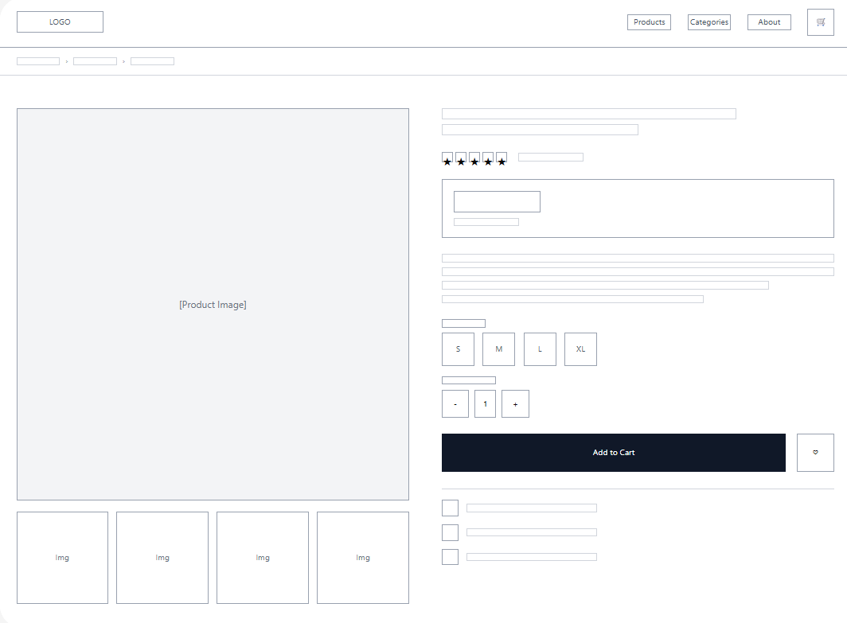

Technical Requirements:
  - HTML
  - CSS
  - JavaScript

Timeline Milestones:
- Week 1
  - Plan: Planning and research of the project
  - Tasks done: Thorough research of the proposal and define the idea of the project
  - Milestone: Project plan complete
- Week 2
  - Plan: Design of the website
  - Tasks done: Draft/wireframe of the project
  - Milestone: Draft complete
- Week 3 - 5
  - Plan: Development of the website
  - Task done: Building the HTML structure of the website
  - Milestone: HTML structure complete
- Week 6 - 8
  - Plan: Development of the website
  - Task done: Incorporating CSS structure to the website
  - Milestone: CSS structure incorporated
- Week 9
  - Plan: Development of the website
  - Task done: Incorporating JavaScript structure to the website
  - Milestone: JavaScript structure incorporated
- Week 10
  - Plan: Finalisation of the website
  - Task done: Testing the functionality of the website
  - Milestone: Website complete and functional

Budget
  - Development: R5 500
  - Hosting: R2 500 per hour
  - Maintenance: R500

References

Limited, W. H., 2026. Woolworths Holdings Limited. [Online]
Available at: https://www.woolworthsholdings.co.za
[Accessed 11 March 2026].
Platform, S. T., 2026. Sourcing Transparency Platform. [Online]
Available at: https://sourcingtransparencyplatform.org
[Accessed 11 March 2026].
Reddit, 2026. Reddit. [Online]
Available at: https://www.reddit.com
[Accessed 11 March 2026].
Studocu, 2026. Studocu. [Online]
Available at: https://www.studocu.com
[Accessed 11 March 2026].
Woolworths, 2026. Woolworths. [Online]
Available at: https://www.woolworths.co.za
[Accessed 11 March 2026].

